**PROPOSED SOLUTION**

Gas leakage is a major problem with industrial sector, residential premises and gas powered vehicles like CNG (compressed natural gas) buses, cars. One of the preventive methods to stop accident associated with the gas leakage is to install gas leakage detection kit at vulnerable places. The aim of this project is to present such a design that can automatically detect and stop gas leakage in vulnerable premises.

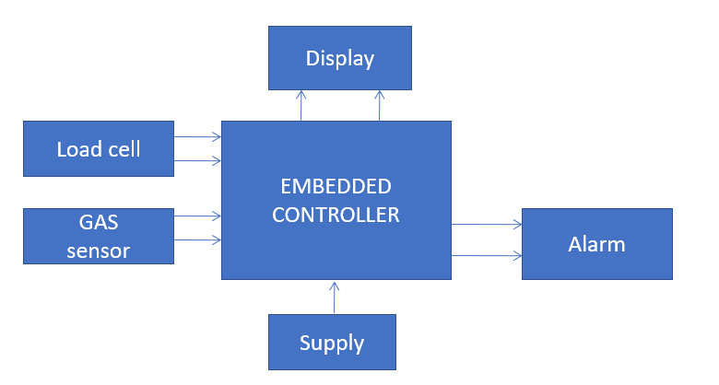

Fig.1.1 Proposed Block Diagram

The proposed system (fig 1.1) makes use of ATmega 328 mircrocontroller. Arduino UNO board is used as a base for the whole system. The system consists of an MQ-2 gas sensor which is attached to it along with a thermostat. These two devices sense the gas levels and the temperature of the surroundings where the system is installed and show the output i.e. the readings on an LCD display. An Ethernet shield is attached to the Arduino UNO board which is loaded in the program code for sending alert to the user. Once the gas levels increase above a pre-defined level, the device sends an alert notification to the user. The user can control devices attached to the system via a relay like, exhaust fan, temperature sensor(lm35), LCD and a motor for closing the gas valve. These devices can be switched on/off by the user using a sytem which supports the Arduino configuration.

**MICROCONTROLLER:**

Based on the ATmega328 (datasheet), the Arduino Uno is a microcontroller board It consists of 14 digital input/output pins (of which 6 can be used as PWM outputs), a 16 MHz crystal oscillator 6 analog inputs, a USB connection, an ICSP header, a power jack and a reset button. You just have to simply connect it to a coputer with a USB cable or power it with an AC to DC adapter or battery to get started as it contains everything it needs to support the microcontroller.

**GAS SENSOR:**

The MQ-2 is an easy-to-use LPG (Liquefied Petroleum Gas) sensor which is highly suitable for sensing LPG, which is mainly composed of butane and propane, concentrations in the air. Gas concentrations of anywhere from 200 to 10000ppm can be detected by MQ6 sensor. The sensor comes with a very high sensitivity and a fast response time. The output of this sensor is an analog resistance. You only have to power the heater coil with 5V, add a load resistance and connect the output to an ADC, which makes the drive circuit very easy.